A Tale of Three Tables
Dr. Aleš Musar

presented at European Wood Policy Platform’s (WoodPop) 4th High Level Meeting
InnoRenew CoE Izola, 15.10.2025

The first days of January 1821 were not very cold. In fact, the whole winter was mild. It was an exciting time for the Duchy of Carniola, the north-western part of what is now Slovenia. Its capital was preparing for the most important political event in its history: the Congress of Ljubljana. It was one in a series of high-level meetings following the defeat of Napoleon and the Congress of Vienna, arranging a new order in Europe. In 1821, the most troubling problem for the victorious rulers of the Holy Alliance was the situation in Italy, where majority of conservative forces wanted to abolish a liberal constitution of the Kingdom of two Sicilies and return king Ferdinand to the throne in Naples. Ljubljana was a good location for a meeting, a city in Austrian Empire yet close to Italy. Preparations started months before the scheduled start of the Congress in January. Austrian emperor Franz I., Russian tzar Alexander I. and King of Naples were expected, along with delegations of all European powers.

Prince Metternich, the Chancellor of Austria, selected the palace of Baron Žiga Zois as the main venue for talks. The Baron, who was a leading figure of Carniolan and Slovenian industry, commerce, science and arts, died just recently. His mahogany writing desk in his Brdo castle estate stood unused.
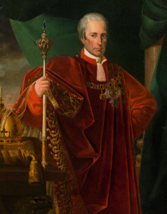
Two parties were outside in the first days of January 1821. The first was Emperor Franz and his retinue, who arrived to Ljubljana on the 6th January. To make his Carniolan subjects happy, just a day before his arrival, a proclamation was issued abolishing taxes on marriage in the Duchy. Prepared well in advance, it must have made an impact on the people of Slovenia: the birth rate in the following years was at its peak.

The other party which was outside in the winter morning of early January might have been discussing the Emperor’s proclamation. They were woodcutters going to fell some mighty oak trees in the hills of Škofja Loka, not far from the estates of the late Baron Zois. Some of them might have been young enough to consider marriage rather than facing conscription to the imperial army. We do not know their names, but there are likely to be Franc and Janez among them, that being the most common male names of the time. We do know the trees they cut: oaks which were growing for well over 100 years.

The Congress of Ljubljana ended in four months with suppression of the revolution in Naples and with a resolution that in case of tensions the rulers will have a debate first before the armies start to shoot. The wood which was cut in the same winter was left for over a year before being used to build a “topler”, a double haystack so typical for Slovenian landscape. When it was finished, they carved a year of construction in the beam: 1823. It was built to last for centuries.

Over a hundred years have passed. The business empire of the Zois family crumbled in the 19th century under pressure of more competitive industries and due to the successors of Baron Žiga being more interested in art and science that in management. One of the last things to go was the castle of Brdo. Before the sale of the estate itself, the furniture was auctioned in 1929. The mahogany writing desk of Baron Žiga Zois was purchased by family Naglas, the leading manufacturers of furniture in Slovenia.

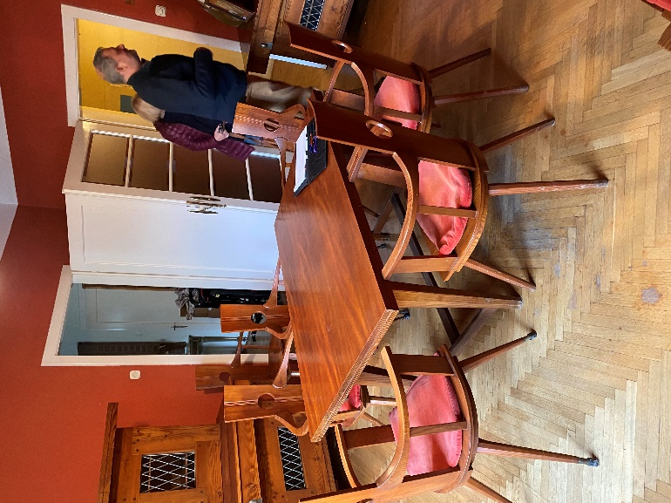
In the same year a writer from Ljubljana Ferdo Kozak was getting married. He was a good friend of already very famous architect and designer Jože Plečnik who returned to Ljubljana after many years in Vienna and Prague where he rebuilt the Hradčane Castle into presidential office and residence. He was very busy with public projects and only friendship with Ferdo Kozak persuaded him to accept the private commission of Kozak’s father-in-law to design furniture for the newlywed couple. Two reception rooms and a dining room were not produced in Naglas factories but in one of the several small carpentry shops making exceptional furniture. They were located around Ljubljana and all the way to Gorenjska, carrying the tradition from the past and passing it to future generations - all to the present days. Another private commission of Plečnik at that time was architectural design for the home of his friend Matko Prelovšek, grandfather of the leading expert on Plečnik’s work Damjan Prelovšek.

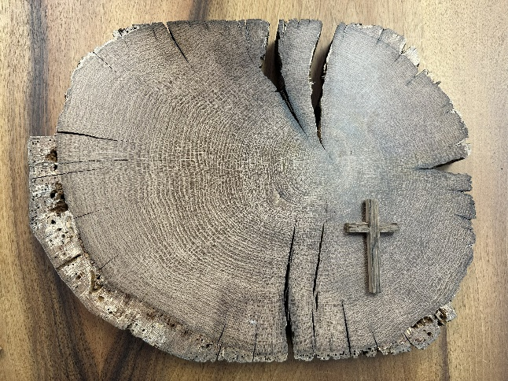
Another one hundred years later, and the toplar which stood proudly for almost two centuries succumbed to the forces of time. It survived a succession of five countries and welcomed the independent Slovenia. It took 30 years for the country to get its first female president, my wife. In fact, the last time the lands which now form Slovenia were ruled by a female was while the oak trees which gave its wood to build the toplar were still growing. Empress Maria Teresia was born and died while those trees were still in the woods. The owner of the farm decided to rebuild the toplar and stored the wood from the old one. After two hundred years the wood of the main beams was still healthy. He decided to use at least the beam with the carved year 1823.
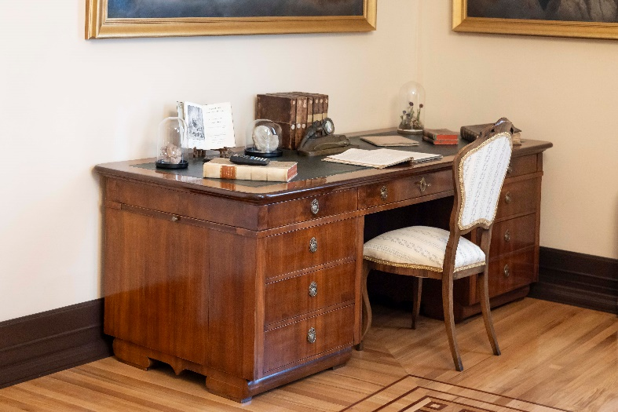
The writing desk of Baron Žiga Zois is still owned by descendants of Naglas family. Jana Valenčič, an architect, lent the desk to the Office of the President. In recognition of its historical importance, it stands in the President’s office with artifacts from the Zois lifetime reminding us about the stories of Slovenian arts and sciences originating in his time, and some of them at this same table.

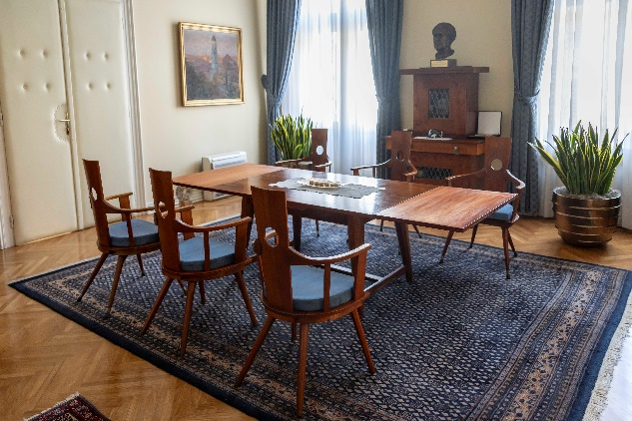
The dining room designed by Plečnik for Kozak family was also lent to the Office of the President by the grandson of Ferdo, rather than being stored in a museum depot. It still belongs to the family, but this product of superb workmanship and designed by arguably the greatest Slovenian architect is now used as the President’s private meeting and dining room. Many important working meetings were held at this table.

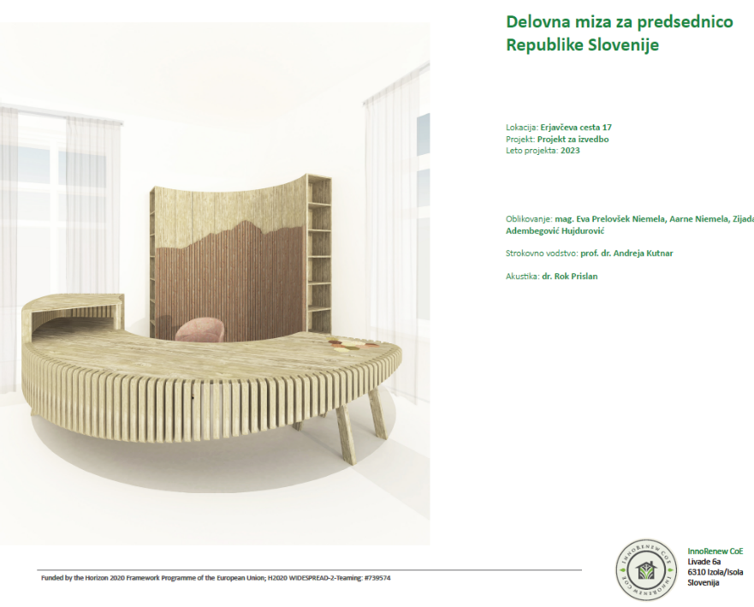
Inclusion of both historical tables in the Office of the President is a result of a conscious policy of furnishing the premises with works of arts and crafts which tell stories about Slovenian history, nature and achievements of its people. This is why a proposal for a new presidential writing desk was accepted enthusiastically. Particularly since its main architect presented a philosophy corresponding with our way of thinking. The design was made in Izola, in InnoRenew, and the lead architect is Eva Prelovšek, the great granddaughter of the aforementioned friend of Jože Plečnik. The project draws from both traditions: Slovenian design and Slovenian craftmanship, utilizing the material which is quintessentially Slovenian: wood.

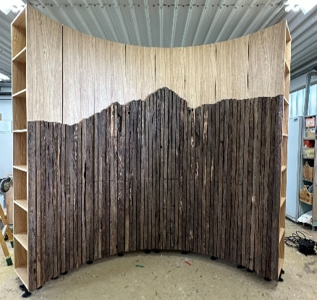
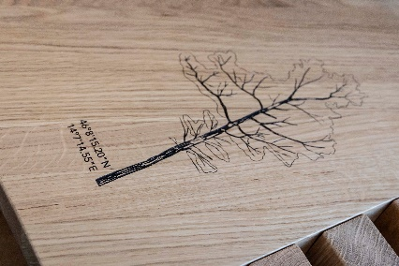
About 50 people were involved in the design and production, making it a truly transdisciplinary project. It incorporates stories and stories within the stories. It is made of oak which grew in the same wood as the one in 1821. Geolocation is incised in the surface and QR code leads to a video of its felling. Parts are made of reused oakwood from that two hundred years old toplar and form a silhouette of Triglav, the highest mountain in Slovenia which is also depicted in our coat of arms.

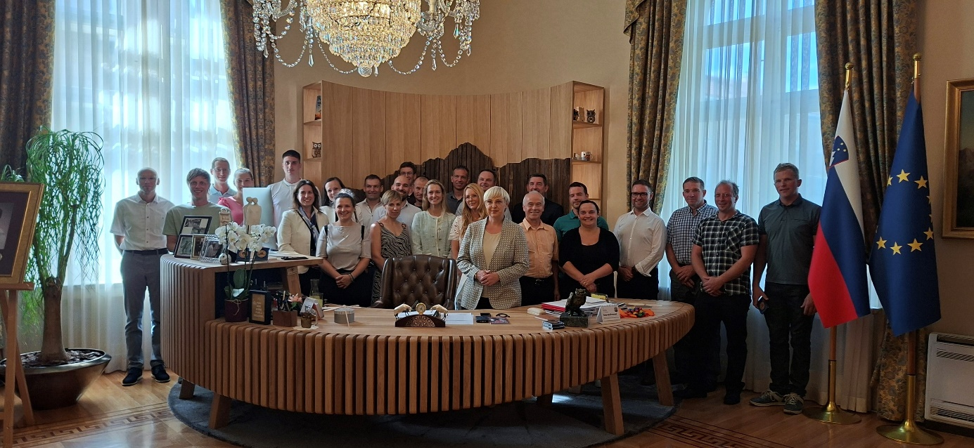

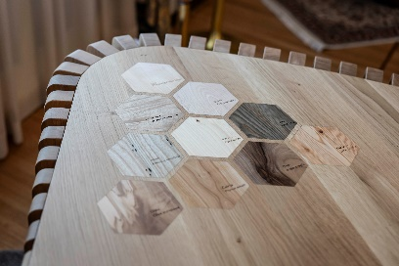
Samples of 10 Slovenian types of wood are inlaid in the surface, and each of them has its own story. 6000 years old fir tree preserved in a marsh; ash wood from old skis produced decades ago in Slovenia, and so on. Even the tale of creation of the new President’s desk is a story in itself.
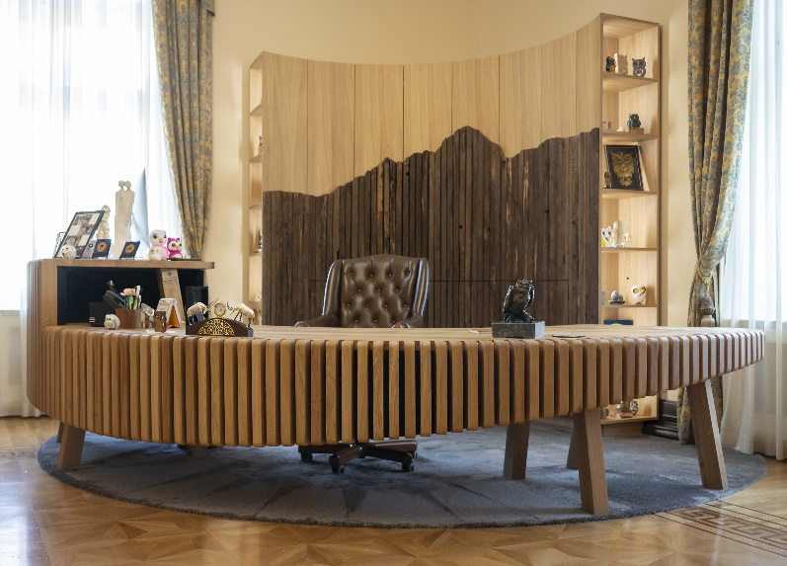
The three tables in the President’s office symbolise the past, present and future of Slovenian wood. They tell stories of the past centuries, show what Slovenian design and craftsmanship can produce in the present and point the way to the future.

