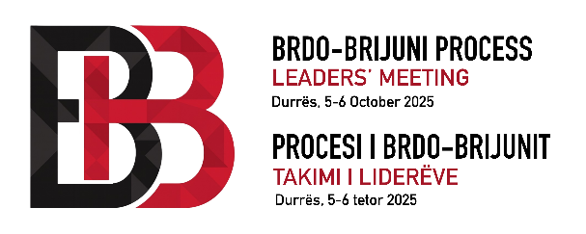

JOINT STATEMENT
BRDO-BRIJUNI PROCESS LEADERS’ MEETING
DURRËS, ALBANIA, 5-6 OCTOBER 2025

We, the leaders of the Brdo-Brijuni Process, guided by the principles of good neighborly relations, regional cooperation, democracy and rule of law, gathered in Durrës, Albania, on 5-6 October 2025, under the topic: “Mutual Interests, Shared Commitments for a Common Future: Advancing Together Towards the EU”.

Bearing in mind Montenegro Presidential Statement of 2024 we agreed on the following:

We reaffirm our commitment to support European integration and inclusive regional cooperation with the objective of a peaceful, strong, stable, prosperous and united Europe,

We continue to promote good-neighborly relations and sustainable development as indispensable basis for achieving and safeguarding peace, stability, prosperity and regional economic integration, to the benefit of our citizens;

We highlight our shared vision towards the European perspective of our entire region, as a key pillar to achieving peace, security and prosperity, as well as social coherence and economic convergence;

We welcome the efforts made so far by the EU to streamline and strengthen the merit-based enlargement process through a number of targeted financial instruments, intensified political dialogue and enhanced policy engagement.

We underline the importance of maintaining momentum in the EU accession negotiations, recalling, that the enlargement process is based on the principle of own merits and on the adherence to the established criteria and fundamental values of the EU.

We recognize the adoption of the EU of the Reform and Growth Facility by the European Parliament and the Council and approval of the respective Reform Agendas by the Commission. We acknowledge the Facility’s role in further accelerating the EU accession path of the Western Balkans by providing additional financial assistance upon the implementation of fundamental reforms.

We commit to embracing the opportunities that the EU Growth Plan presents. These include increased regional economic cooperation, access to EU financial instruments, trade facilitation, integration of industrial supply chains and the facilitation of digital and energy transitions to align with EU standards. We will continue to work on facilitating the economic and social transformation of our societies, paving the way for full EU membership while adhering to the merit-based principle of accession throughout this process.
We continue to attach great importance to addressing the issue of brain drain in the Western Balkans, particularly in terms of research and innovation, showing that a significant number of young people are aspiring to leave their homes in seeking better opportunities abroad.

We underline the importance of EU collaboration and support in keeping the youth in the region. EU’s engagement and partnership are crucial in ensuring the full implementation of youth strategies.

We welcome the recent meeting of the Directors of Employment Agencies and encourage future cooperation in that format. In this context, participants will strive to develop policies and programmes to counteract brain drain, particularly among young people, and the associated loss of human capital necessary for economic development and prosperity in the region.

To this end, they will seek to strengthen cooperation between public employment services with the aim of promoting quality employment, enhancing job opportunities, improving the alignment of education and labour market needs, improving working conditions, creating an attractive social environment, and developing programs for the return of talent.

Cooperation will include the exchange of good practices in targeted measures for young people, including the prevention of brain drain, experiences in implementing the Youth Guarantee initiative, support for circular mobility of workers with the option of return, enhanced digital transformation of PES and the creation of sustainable employment for the younger generation.

We express our deep concern over the ongoing global conflicts, which caused many civilian casualties, and which have disrupted international supply chains, aggravated food insecurity, damaged the environment, caused deliberate cultural heritage sites and objects damage and destruction, heightened energy vulnerabilities and caused humanitarian crises.

We recognise the importance of solidarity and coordinated responses, both at the regional and global levels, to face an unprecedented set of challenges, ranging from geopolitical tensions to economic instability, migration pressures, global health, and triple planetary crisis of climate change, biodiversity loss and pollutions.

We stress the need for enhanced cooperation in addressing security concerns, including organised crime, terrorism and hybrid and cyber threats, including dissinformation, which pose risks to the stability and prosperity of our societies.

We underscore the importance of strengthening regional resilience by enhancing connectivity, promoting economic and energy supply diversification, digitalisation, building efficient and accountable institutions and fostering partnerships that contribute to greater sustainable development.

